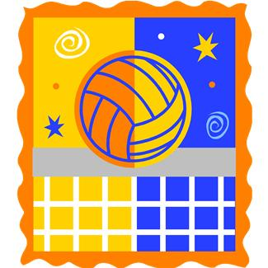

**Cost**

$180 for 12 kids including birthday boy/girl $12 per extra person

Includes 2 Pizzas,12 Soft drinks/Water/sports drinks, Staff, paper goods

$30 for additional ½ hour for activity space or party area,

$45 for 30 min of Pool (Eastmoreland Only)

You may bring in your own Birthday cake and Ice Cream

Appropriate Shoes and attire is required

Sample

Schedule of Activities 1.5 hr

Tour of facilities for all guest (5 min)

Activity in your area( Bball, Vball court) 30 Min

Food, Party gifts in the party area 30 Min

Activity in your area 30min

+

Birthday Parties

Basketball, Volleyball, Swimming

activities

For more information and securing dates contact:

Eastmoreland Courts Neal Franzer 503-653-0820

The Courts in Beaverton Jeanette Lee 503-646-7905

www.TheCourtsinBeaverton.com